**One Shot One Kill Model**

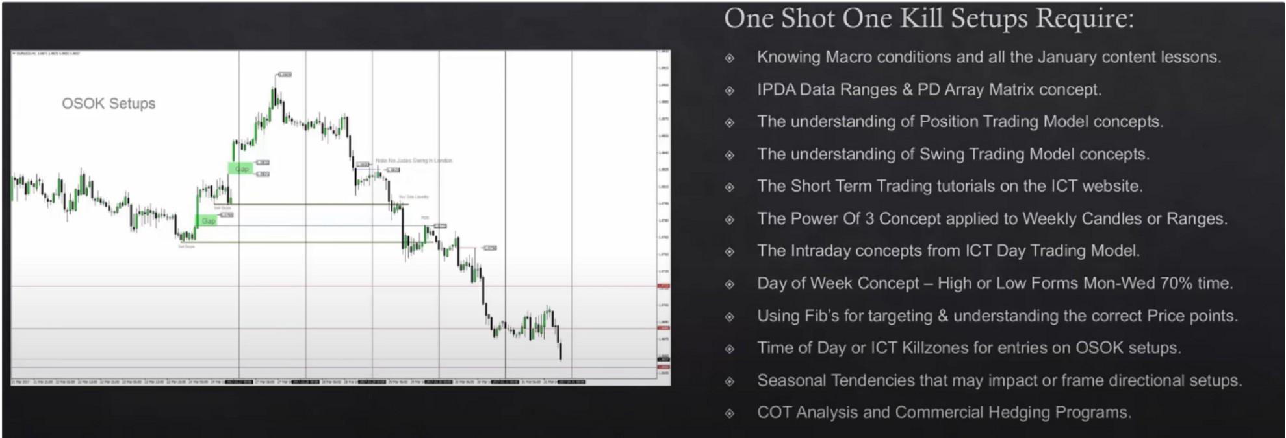

lntraday concepts will fill in the gaps of this month, you need intraday concepts to get really precise, but you dont need it to do one shot one kill

You have analysis paralysis becasue you simply dont have a procedure of using all the information Swing analysis are the price swings inside larger swings etc

We want to get in when the market is quiet because we expect an expansion with larger ranges

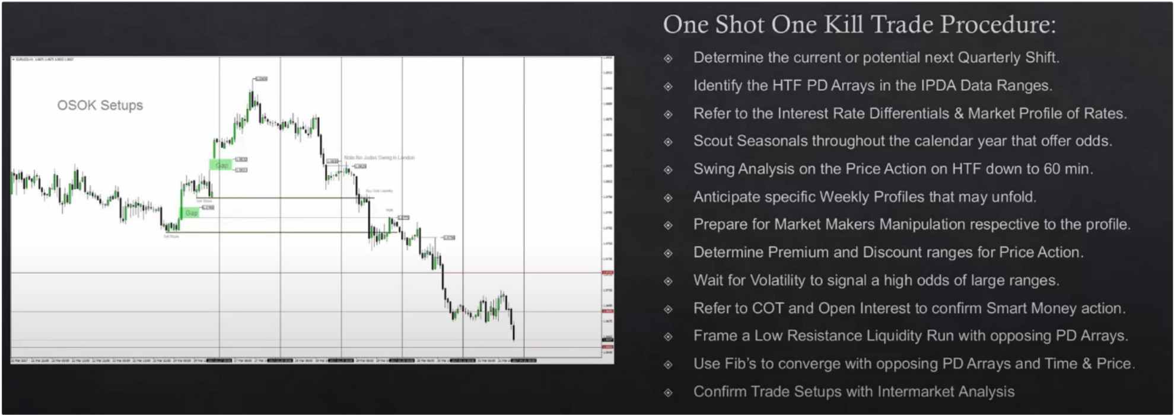

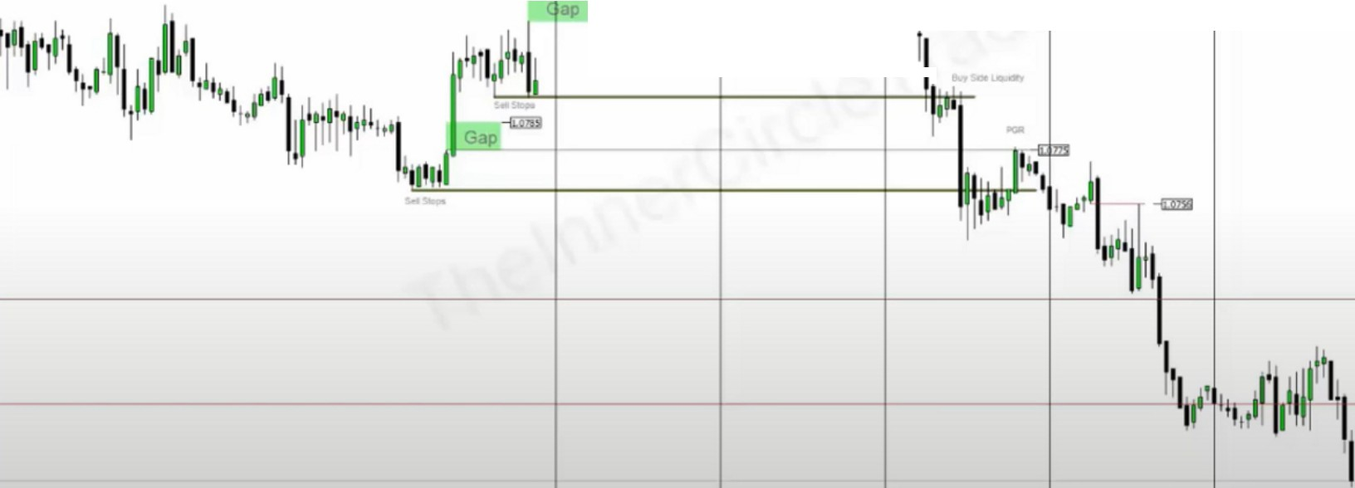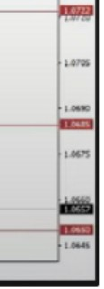

**OSOK Setups**

Ii

1

I'

111,1

I

1I 11·1, tt,

1u•l1j11,jll

**-Oll**,**i**

**1,** N No.......,.,,.,, ""

,,i• I**',-ois**

I

**Jl**

**ll_l_**

1st thing, seasonal tendency

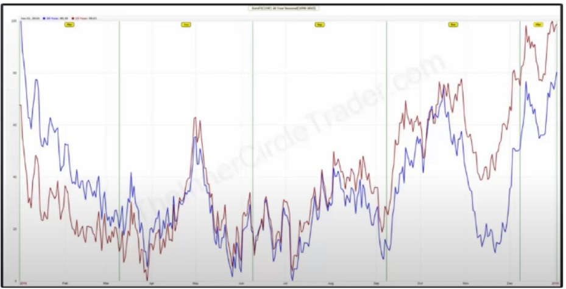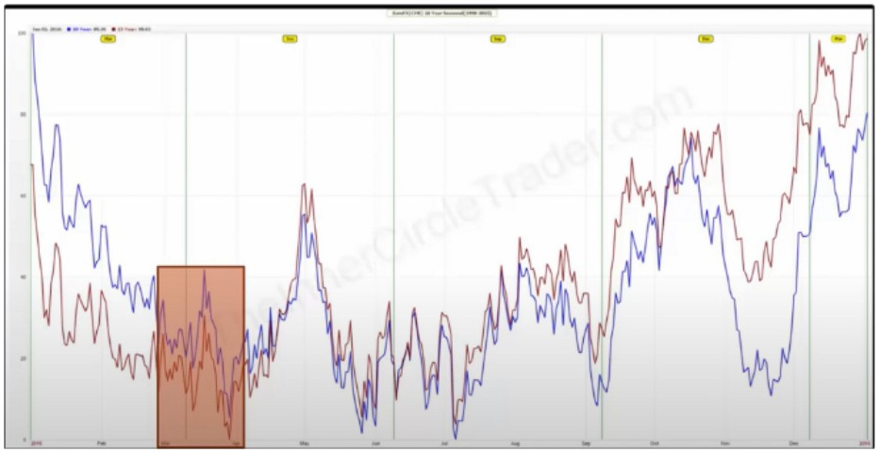

2nd thing, COT hedging program ICT uses paint to edit his COT

Only look at the net position, net position is all the longs and short and you can see if there are more shorts or more long

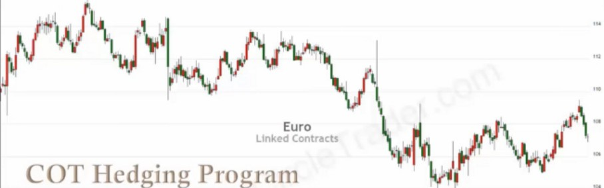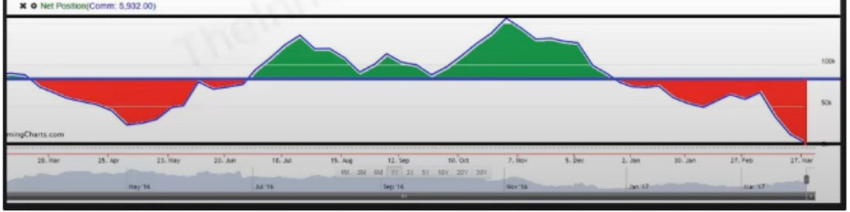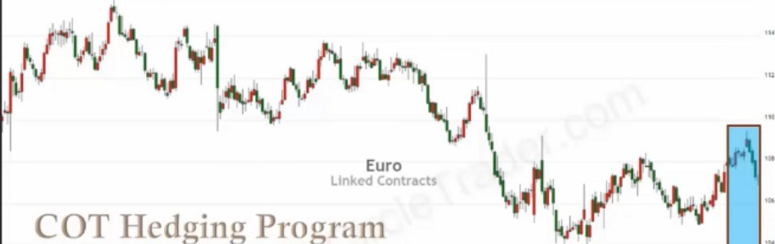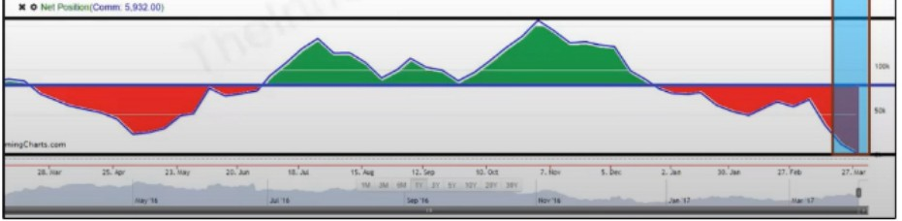

Theyre selling aggressively into a rally, so commercials are looking to sell and seasonal tendencies are to go lower

Open interest is not that important here, because we already have 2 things blending together. And you really only need 2 things blending together for smart money

How to justify these ideas, there has to be lining up something technical Dollar index:

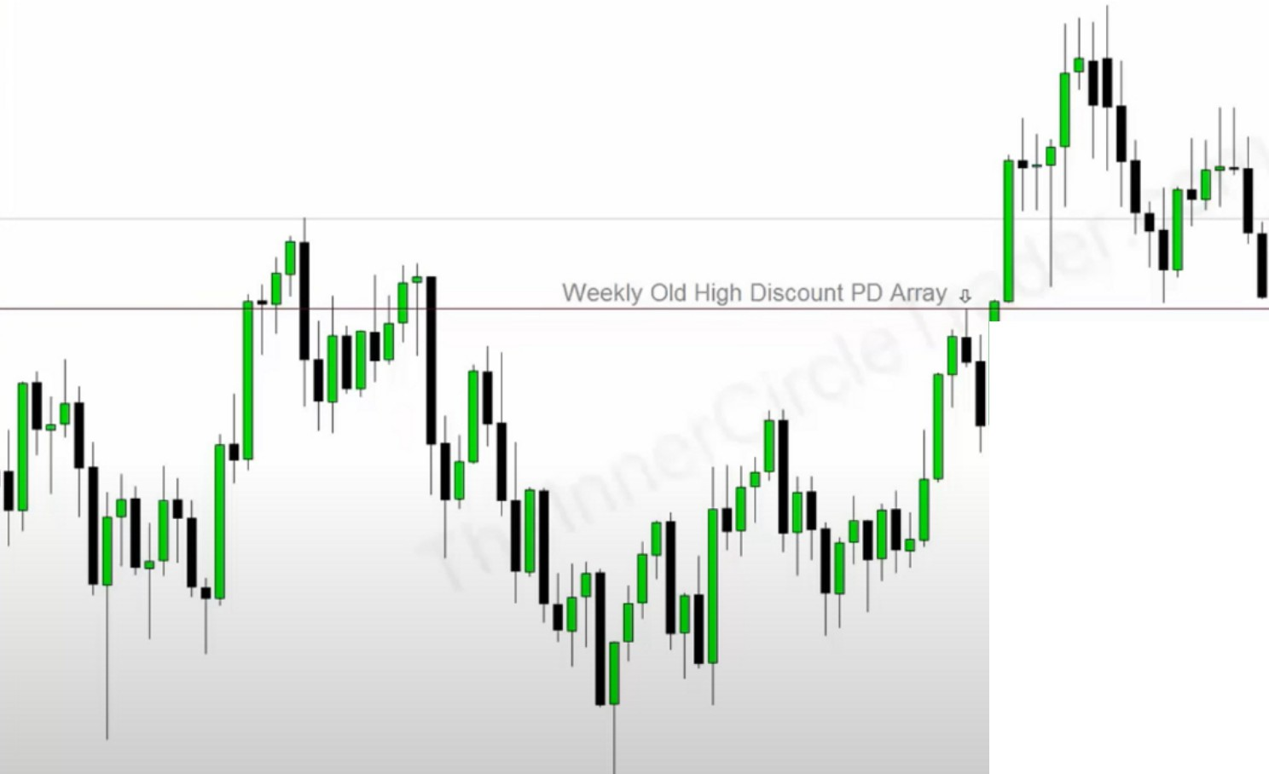

0

-

-D

-

-

..

'==•»--=••- n._,_s-==•._- . - u-=-0=-==•••1=-cc-• =-=-•-=-"'",'-c=---c,-- -•=--a==-»- ••-=.,..,- ... --=• - o--=-c.=110..-..,.c.-,=,.,..., ,-=--.,-- ••



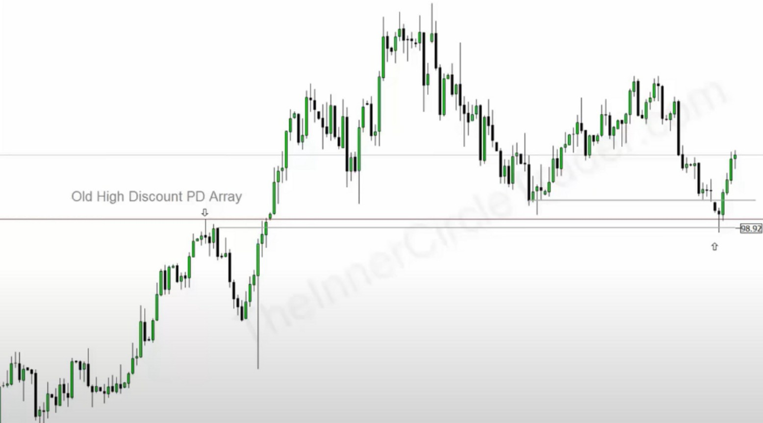You could round it down to 98.90 but generally the rule is that we round up to the nearest 5 or 0 level, so 98.95

|  |  |  |  |
| --- | --- | --- | --- |
| *I* **..11s-s11** | |  |  |
|  |  | |  |
|  |
|  | | |

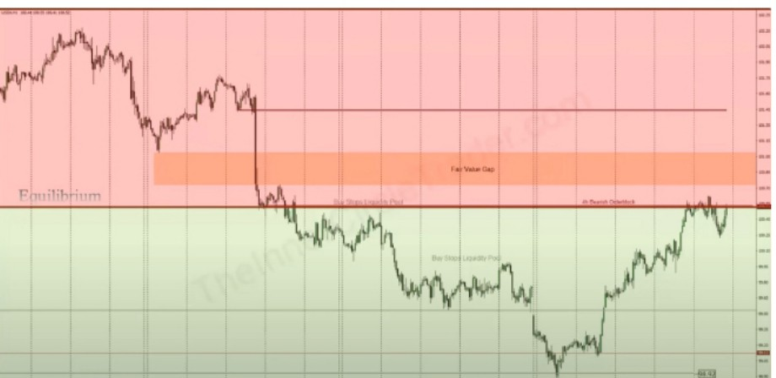

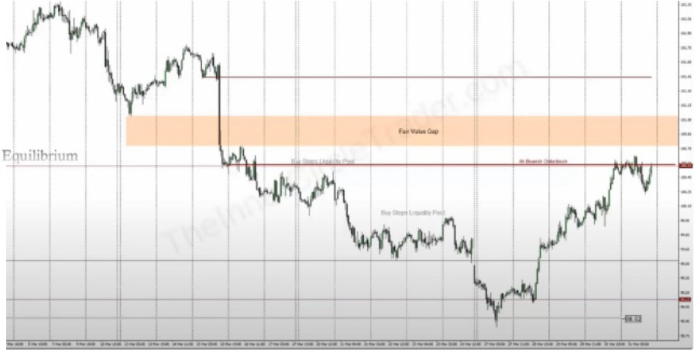Discount will most likely pull back to EQ and then we have to look if it wants to go to premium or back down in discount, we dont know that

Use IPDA data ranges and the PD array matrix, blend time and price

lntermarket analysis, EURGBP

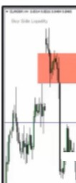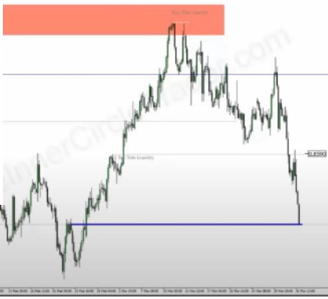

\N\

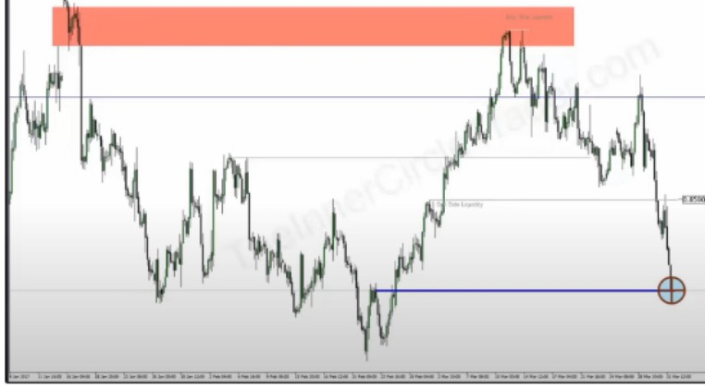

If we want to see weak EURUSD then EURGBP should be weak as well EURUSD technical

**.1\J.1...1.1. .. l.1,.l,.J .I.. .l.1b .. 1** \...._,-j_ **,\L'--l\. .I.** *.l\l.1. • .1.\...,*

[ I he llne Shnt One Kill I

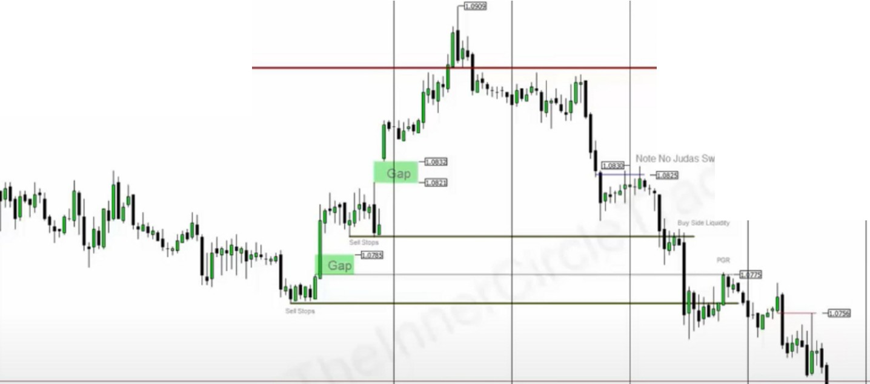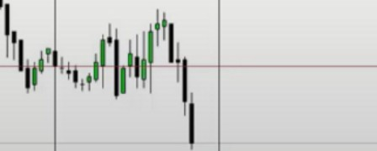

OSOK Setu s

**Weeki Bearish Orderbl ck**

....

How far do we expect the weekly orderblock to trade into? Thats going to be discussed on the last slide of this teaching

Expecting MTW to be the high of the week

We immediately trade up into the weekly orderblock on monday, so right away we can assume that monday will be the high of the week

|  |  |  |
| --- | --- | --- |
|  |  |  |
| . **Gap**  **--- -!illl)**  I 1l 11111,,11i1111ii,",1' 11,,11I"'ii  Gp | |
|  | |
|  | | |

What we do on monday, we look for price to trade up and have a retracement intraday London session had a retracement and then an expansion all trough new york

ICT measured the swing from the high formed in London down to the retracement low prior to the new york session rally, ICT measured that swing intraday and it gave the 1.0909 level

By doing that we can see and project the weekly high, more will be in the intraday teachings

We aim for the liquidity void on a lesser timeframe, because we came from the weekly OB, so now we have an anticipated range

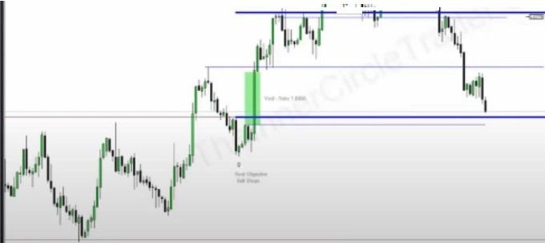

i•:,l M ­

f'1, [M '1

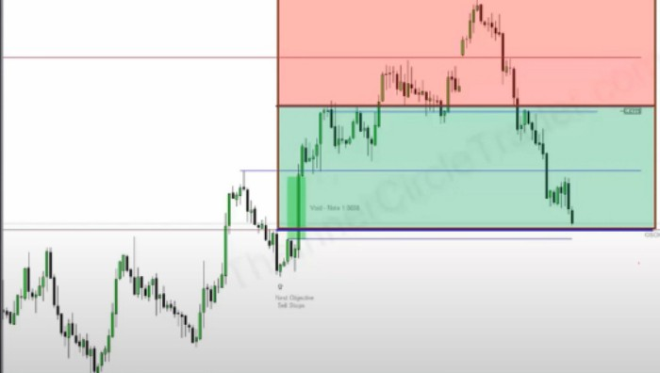

He didnt talk about actual entries? Maybe he will talk about it in later teachings

This is how you can be so accurate, blend it all together, its the nearest thing to perfectiong. This is how you can call things to the pip

When you finish the mentorship do it all over again, watch everything again. Then you will have everything you need to know

August month 12 will have a procedure from top down, regardless of what trader you want to be.

Arjo I Twitter, lnstagram I Linktree

Linktree. Make your link do more.

1 https://t.co/HhmmTN1fUI

JavaScript is not available.

'I# https://twitter.com/arjoio